**Homework Policy**

Assigned Monday through Thursday, generally due the following school day for full credit unless otherwise noted.

**Science Learning Objectives:**

Daily instruction will expand our students’ way of thinking and investigating processes, principles, and theories of science by engaging in engineering practices about the natural world. Instructional practices will follow standards and expectations of what students will be assessed on for the Georgia Milestone.

Learning Strands: Earth and Space, Physical Science and Life Science

**Grading Policy**

Richmond County School System will use the following grading system for grades 4th and 5th for 2024-25 school year

A 90-100 B 80-89 C 75-79

D 70-74 F 0-69

**Course Projects**

Science Fair information and major projects will be announced as the year unfolds.

**Course Assessment Plan** Every unit will consist of a Pre and Post Assessment. Your child will receive scores based on their classwork, homework pop-quizzes, weekly tests and class participation.

**Instructional Philosophy**

Each 5th-grade classroom will demonstrate an environment full of rigor and relevance. Individualized instruction will be used to support students with different learning styles and learning modalities. This will be done through the use of videos, PowerPoints, paired activities, individualized assignments, and various hands-on activities. Daily lessons and activities will include the use of [technology](http://712educators.about.com/cs/technology/a/integratetech.htm) and individual guided instruction to provide an environment where children will use self-discovery and a hands-on approach to learning.

Dear Parents

I would like to extend a warm welcome to you and your child to the 2024-25 school year! I am looking forward to a productive partnership with you to ensure your child can achieve his/her highest potential. I recognize that to be successful in school, children need support from both home and school. A strong partnership with you will make a great difference in your child’s education. As partners, we share the responsibility for our child’s success and I want you to know that I will do my very best to carry out my role of educating your child(ren) in a safe and nurturing environment.

The curriculum’s foundational platform for fifth grade will focus on essentials for ELA, Mathematics, Social Studies, and last but not least, **SCIENCE**.

Weekly instruction will also be received in Physical Ed., Health, Music, Art and STEM.

**Fifth Grade Science Syllabus**

**&**

**Welcome Letter**

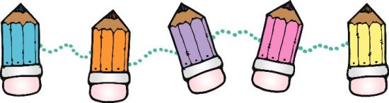 

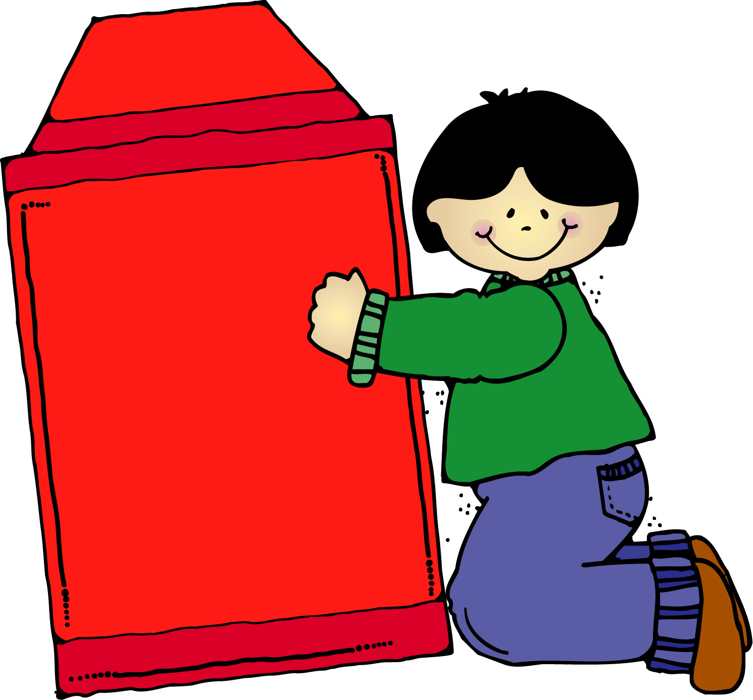

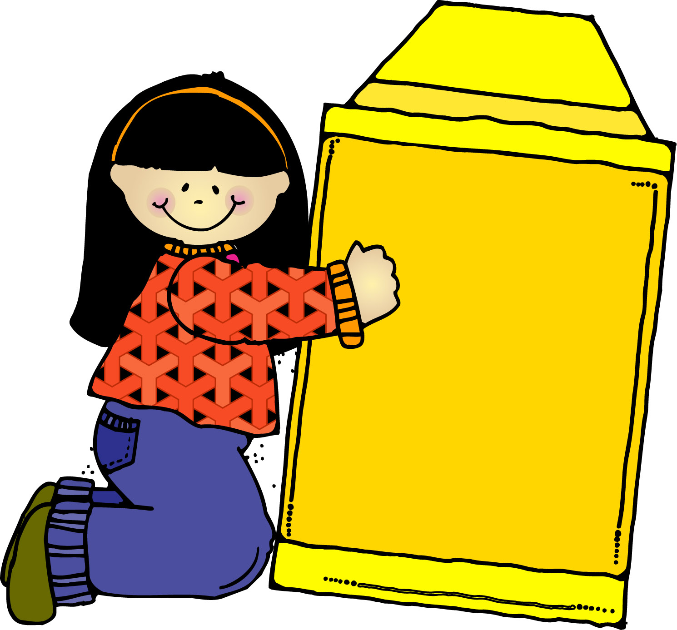

**Student Code of Conduct**

* Refer to the Student Code of Conduct booklet for procedures concerning tardiness and absence, early release, dress code, medicine policy, illness at school, and withdrawals

**School Day Schedule**

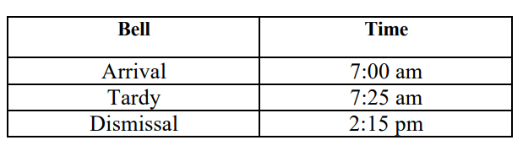

**Breakfast is served from 7:00 am to 7:25 am**

**Mrs. Williams Contact Information:**

**Classdojo**  **Email Address**: [willian4@boe.richmond.k12.ga.us](mailto:willian4@boe.richmond.k12.ga.us) **Phone:** (706)795-4985

**5th Grade Supplies and Materials**

5 composition notebooks

#2 pencils (NO MECHANICAL PENCILS)

Erasers

Graph Paper

1 pack of notebook paper

1-4 inch 3 Ring Binder

Dividers

Headphones (no beats, no earbuds, no airpods)

2 Glue sticks

Colored pencils (12-24pack)

1 box of markers (12pack)

2 plastic pocket folders with prongs

Wish List Items: Clorox or Lysol wipes, Kleenex, hand sanitizer, Ziploc bags (quart or gallon size), individually wrapped snacks/treats

**Transportation:**

Changes to the normal method must be in writing and submitted during homeroom. Parents may send a ClassDojo message no later than 1:00 pm.

**NO EXCEPTIONS**

The 5th grade team will follow the school-wide behavior plan.

**Consequences**

1st Offense: Verbal Warning

2nd Offense: Reflection Time

3rd Offense: Parent or Guardian Contact

4th Offense: Office Referral

**Our School’s Motto:**

Bee Responsible

Bee Respectful

Bee Safe

Bee a Good Listener

Bee The Best Student You can Be

**Classroom Expectations**

* Students should report to school on time, and be prepared and eager to learn
* Students are expected to follow school and

classroom rules at all times

* Students are expected to remain on task

throughout the school day